Chestnut Talented and Gifted Newsletter

April 2020 www.chestnuttag.com
Principals Corner

Dear TAG students and Families.

I hope this finds you all well and managing the stress of this time of isolation. While the school is closed, we are working daily/remotely to identify best ways to support students academically and social-emotionally. By the time you read this, you will have heard from us regarding our plan to provide remote learning experiences for students, as well as Advisory student meetings and calls and supports from counselors. Despite the shutdown, we continue to be fully committed to supporting the needs of our students as best we can, from afar. Please continue to reach out to us during this time in ways that we can support. We are answering and getting messages that go to the school phone number, but we also have our google number that Ms. Cooley-Strom responds to which is 413.455.0069. Please don't hesitate to reach out.

We also want our students and families to find and join us on Instagram at Chestnut_Tagschool, Facebook @Chestnut Talented and Gifted Middle School and our website is being updated daily (www.chestnuttag.com).

These are times when the more we can do to stay connected, the better we will all fair to get through this. I especially want students to know that we miss you, missing seeing you and supporting you and we look forward to connecting with you remotely. Stay safe and stay strong. We will all get through this together.

Dr. O'Connor

National Days in April

April 2nd- World Autism Awareness Day

April 6th- Student Athlete Day

April 10th- Good Friday

April 15th- Tax Day

April 22nd- Earth Day

Chestnut Talented and Gifted Newsletter
April 2020 www.chestnuttag.com

Staff Spotlight- Janelle Clarke – Humanities Coach

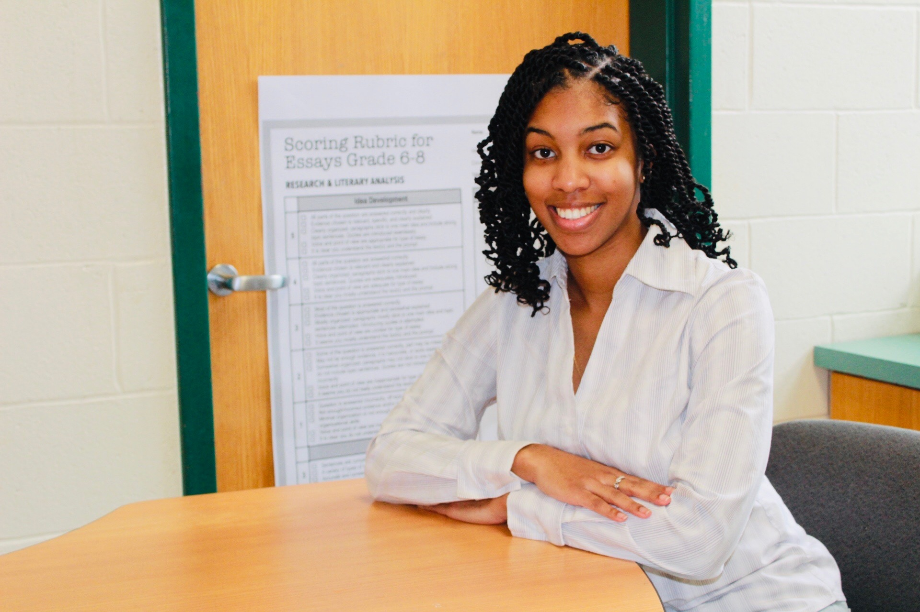

I am a Springfield native, born and raised. I attended The Renaissance High School as part of their second ever graduating class. After high school, I attended Merrimack College in northern Massachusetts. I always knew I wanted to be an educator and Merrimack had a great education program, so the decision to attend was a no-brainer. While at Merrimack I had the opportunity to complete teaching hours at Haverhill High School and North Andover High School. I taught all grades, 9th-12th, during this time. When I say, “I don’t teach babies”, I mean it. I began teaching English at TAG in 2016 and life has been wonderful ever since.

Three traits that define me are determined, thoughtful, and humorous (not sure if students would agree with the last one). These three traits have carried me through some of the biggest decisions I have made to date. They have also helped me stay focused and disciplined which has led to many transformative opportunities/experiences.

I hope that my greatest accomplishment is leaving some gem of knowledge within students that they utilize way after they have had my class. Whether that nugget of knowledge is related to English or life, I hope something positive and powerful sticks with some students and provides aid to them later on.

True leadership is being able show and encourage others to grow positively as you all work towards the common goal. True leadership also means knowing how to communicate with and appreciate others as you try to accomplish the goal.

Success is when my students are proud of their work.

I would tell my 13-year-old self to not be scared. Life at that age, going to high school and such, is very nerve wrecking. However, you are the one that can make the best of a situation “or nah.” So, don’t be scared, be yourself, and everything will be okay.

Guidance Corner

During these uncertain times we can find ourselves not knowing what to do with the extra time that we now have. If you are having difficulty here are some tips for you and your child.

Create an at home schedule:
Have specific times for waking up, meals, exercise, work, play time.

When we have too much time on our hands our brains tend to make up stories, be intentional with everything you do.

The guidance team will be checking in with students on a weekly basis, we intend to continue working with our students and provide the supports they need.

Guidance Google Numbers:
Mrs. Staine- 413-342-1408.
Mr. Vanasse- 413-351-0629.

To keep our birthday traditions going, if your child has a birthday during the school break, we will connect with you for a Zoom Birthday call. Teachers and guidance will call and wish your student a Happy Birthday.

8th Grade-
High School acceptance letters will be mailed home at the regular scheduled time. Letters should be received by April 13th.

Please continue to check your emails and follow us at www.chestnuttag.com for updates.

The week of April 6th- 10th we are having Virtual Spirit week. Each day is a special theme, follow instructions and post your picture on Instagram.

We would love to have photos of your students completing work, send to Chestnut.tag.middle.school@gmail.com or post on our social media sites.

